*Florida International University*

*School of Computing and Information Sciences*

CIS 4911 - Senior Capstone Project

Software Engineering Focus

Feature Document

User Story # 548

**Team Member:**

Garrett Lemieux

**Product Owner(s)**:

Francisco Ortega

**Mentor(s)**:

Francisco Ortega

**Instructor**: Masoud Sadjadi

**User Story– Draw Lines with leap motion**

* As a User I would like to draw lines using the leap motion device so I can draw on the canvas.
* **Acceptance Criteria**:
  1. User must be able to draw lines using the leap motion.
  2. User interaction while drawing must be smooth and simple.

**Use Case: User Draws with Leap Motion and Gestures Disabled**

User draws with lines using leap motion and gestures are automatically disabled while use is in draw zone.

* Details:
* Actor:
  + User
* Pre-conditions:
  + Leap Motion device is enabled.
  + User has the ability to draw lines with multi touch device.
* Description:
  + Use case begins when User has decided to draw a line on the canvas.
  + User can use his or her hand to interact with leap motion and when finger or fingers enters hover zone a green circle will appear on screen to signal finger location is near drawing zone.
  + User can draw on canvas by moving finger towards screen and entering drawing zone.
* Post-conditions:
  + Any shape drawn using lines will appear if the users fingers were in the leap motion draw zone.
* Decision Support:
  + Frequency: High, User will need to interact with canvas to create pictures.
  + Criticality: High, Allows Users to draw with hands in a way other than touch screen by using leap motion.
  + Risk: High, Had to learn leap motion SDK and how hardware works.
* Usability:
  + Need to be able to read user guide and follow instructions.
  + User must also understand how the hover zone and draw zone work.
  + A user will have to spend some time with the device to get a feel for how it reads his or her hands. Guide will only provide a basic understanding that caters towards a generic hand.
* Reliability
  + Reliable
* Performance
  + - Performance High
    - Failure Low
* Supportability
  + Leap Motion Device
* Modification History:
  + Owner: Garrett Lemieux
  + Initiation Date 02/07/2016
  + Date last Modified: 05/1/2016

**Use Case Diagram**

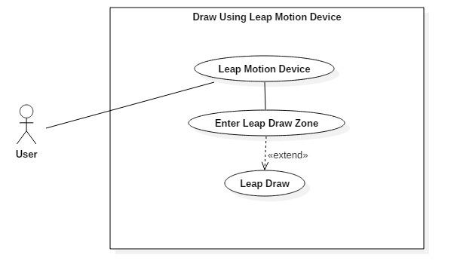

**Sequence Diagram**

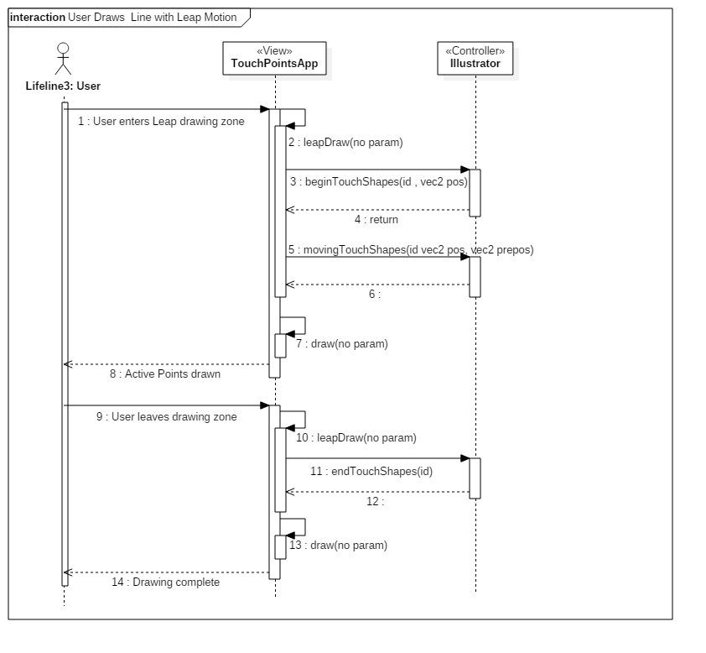

**Class Diagram**

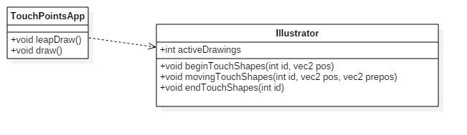

**Unit Test**

* Sunny Day Test:
  + Test Case  - Leap Motion Hover Zone
    - Test Purpose: Test if a user can enter the hover zone and feedback on finger location is provided.
    - Test Procedure: User starts application. Then slowly moves right hand with index finger extended toward screen. Then observes results. This procedure is repeated with left hand.
    - Expected Results: As user’s right hand moves toward canvas a green circle should appear once hover zone is entered by user. Same should occur when left hand is used.
  + Test Case  - Leap Motion Draw Zone
    - Test Purpose: Test if a user can enter the hover zone and expected feedback is provided.
    - Test Procedure: User starts application. Then slowly moves right hand with index finger extended toward screen. He or she enters hover zone and then continues to move toward screen until draw zone has been entered. Then observes results. This procedure is repeated with left hand.
    - Expected Results: As user’s right hand moves toward canvas a green circle should appear once hover zone is entered by user. Once user enters draw zone green circle should disappear and line should be drawn following the finger that is within the draw zone and should appear on canvas at specified location. Same should occur when left hand is used.
  + Test Case  - Leap Motion Hover Zone for All Fingers
    - Test Purpose: Test if a user can enter the hover zone with all ten fingers and feedback on finger location is provided.
    - Test Procedure: User starts application. Then slowly moves both left and right hands into draw zone with all fingers extended toward screen. Then observes results.
    - Expected Results: As user’s right and left hands moves toward canvas a green circle should appear, one for each finger, once hover zone has been entered by user.
  + Test Case  - Leap Motion Draw Zone for All Fingers
    - Test if a user can enter the draw zone with all ten fingers and expected feedback is provided.
    - Test Procedure: User starts application. Then slowly moves both left and right hands into draw zone with all fingers extended toward screen. Then begins to move his or her hands up and then down. Then observes results.
    - Expected Results: As user’s right and left hands moves toward canvas a green circle should appear, one for each finger, once hover zone has been entered by user. As he or she continues into draw zone a drawn points should appear where green circles were previously. As the hands move up and then down, ten lines should be seen on the canvas.
* Rainy Day Test:
  + Test Case  - User exits Real Sense boundaries while in Hover Zone
    - Test Purpose: Test if user exits boundaries while in hover zone expected result will occur.
    - Test Procedure: User enters hover zone and begins to move around canvas. He or she accidently leaves real sense boundary and observes result.
    - Expected Results: When user leaves real sense boundary the green circle should disappear. If green circle remains or program experiences any non-expected actions then test fails.
  + Test Case  - User exits Real Sense boundaries while in Draw Zone
    - Test Purpose: Test if user exits real sense boundaries while in draw zone expected result will occur.
    - Test Procedure: User enters draw zone and begins to draw on canvas.

He or she accidently leaves real sense boundary and observes result.

* + - Expected Results: When user leaves real sense boundary drawing should stop immediately. If program experiences any non-expected actions then test fails.

**Integration Test**

* Leap Motion drawing was testing using each shape and color.
* All devices that have the ability to draw where tested by altering devices that are used to draw without stopping the program.
* After integrating the leap motion drawing into application all previous functionality was retained.

**User Guide**

**User Guide**

* Devices Used: Leap Motion Device



* User can use up to 10 fingers.
* He or she should have palm closed with index finger extended.
* In order to enter hover zone user slowly moves hand towards desired location on canvas and will be provided feedback in the form of a green circle when hand has entered hover zone.

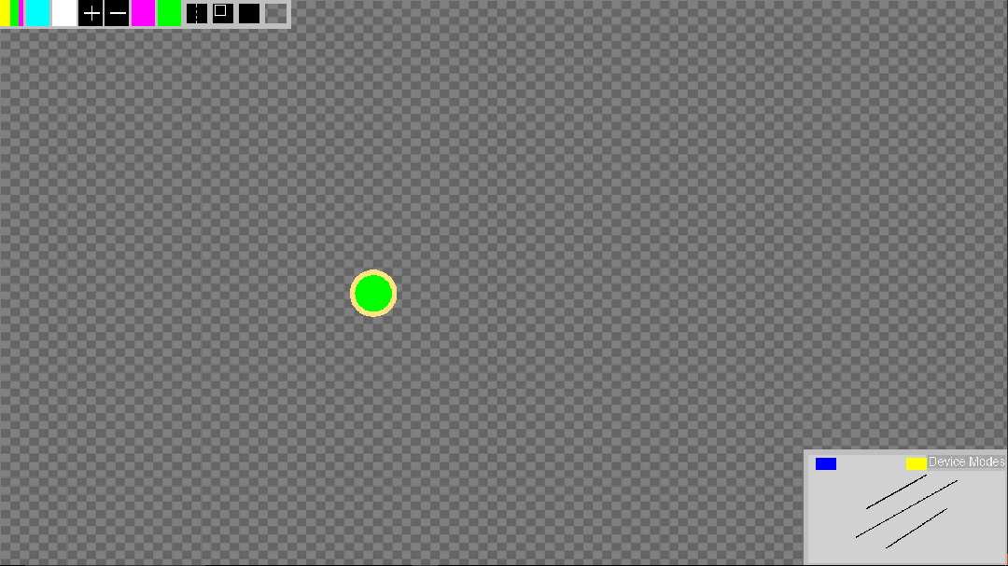

* In order to enter draw zone user must first enter hover zone and then continue moving toward desired location on canvas. Once draw zone has been entered user will see the current shape and color being drawn to canvas.

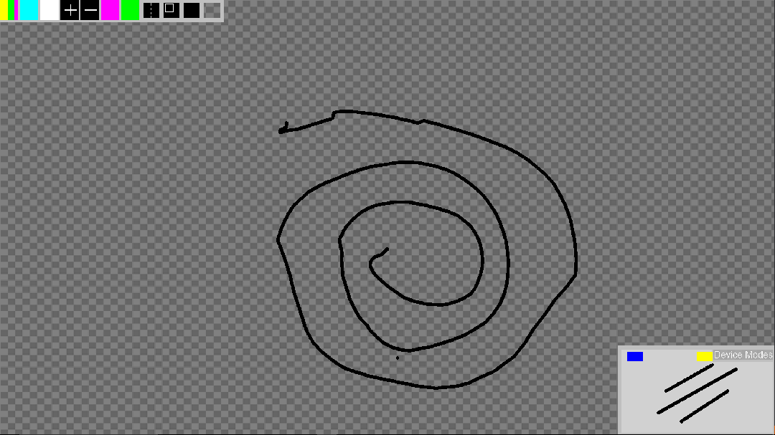

* Once draw zone has been entered user can draw on any part of the canvas by moving his or her hand like a cursor to the desired location on canvas.
* User can expected drawing to stop if he or she tries to draw outside the canvas.

**Glossary**

* **Leap Motion Hover Zone** – Area before draw zone indicates to user current position of user’s finger.

**Leap Motion Draw Zone** – Area where drawing takes places. Draw zone uses a virtual drawing surface in the form of a leap interactive box.